Model No LCV-101
Two bedroom, one bathroom, dinning hall, kitchen, veranda

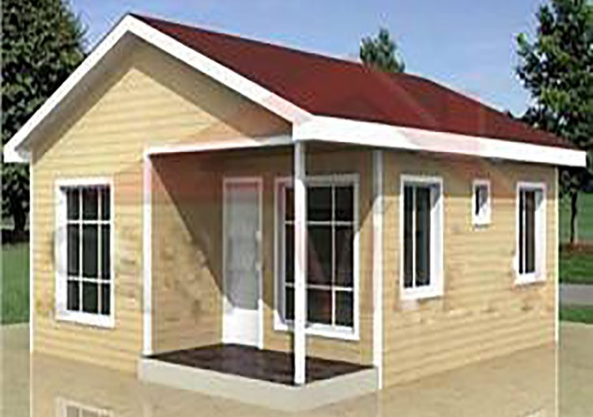

3D veiw

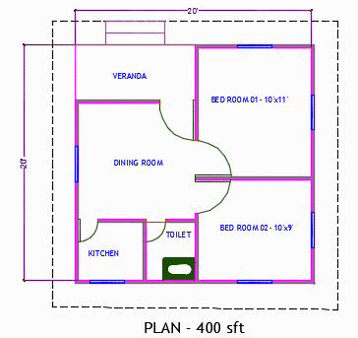

Floor layout plan

Floor Description
- Floor Area 440 sft
- Width 20 ft
- Lemgth 22 ft
- Eave Height 9.5 ft
- Master Bed Room 11ft x 10ft
- Child Bed 11ft x 10ft
- Living Room 18ft x 8ft
- Kitchen 6ft x 6ft
- Common Toilet 5ft x 4ft
- Veranda 6ft x 4ft

Materials Description
- Footing pre cast Rcc
- Tie Beam pre cast Rcc
- Structure Prefab steel
- Roof 0.42mm Color coated steel sheet
- Heat Insulation 5mm pe foam
- Outer wall 2.5’’pre cast Rcc panel
- Inner wall 2’’ pre cast Rcc panel
- Main Door Steel flash Door
- Toilet & Kitchen PVC Door
- Window Glass with MS frame
- Grill 10 mm Square bar
- Indoor paint Off-white plastic Emulsion
- Outdoor paint Light gray weather coat
- Commode Star band
- Bath room fitting uPVC
- Floor finishing Ner cement and color
- Safety tank 2 set x 3ftx5ft ring well
- Water Tank 500 ltr with steel stand

